

**CSE370 : Database Systems**

**Project Report**

**Project Title : Online Quiz System**

| **Group No : 02 , CSE370 Lab Section : 08 , Summer 2024** | | |
| --- | --- | --- |
| **ID** | **Name** | **Contribution** |
| 24341271 | Pranjal Basak | Creating Admin Dashboard, Creating System for Creating, Modifying, Verifying, Deleting and Fetching Quizzes and Questions, Ending User Session after Completing Their Quizzes |
| 22101461 | Zayed Masum | Worked on admin panel files including add_data, add_new_country, checklogin, logout, user_test_credentials, footer and sidebar |
| 22301329 | Farhan Tanvir Niloy | Worked on the admin panel creating files for statistics, quiz stats, question status, view data options and the user profile from the user end. |
| 22301645 | Nabonita Saha | Worked on user dashboard and user leaderboard creating and functionalities relating to it. ( includes showing user details and redirect them to quizzes (not the making of quiz) they can take part in besides ranking along with all the viewing end works ) |

**Table of Contents**

| **Section**  **No** | **Content** | **Page No** |
| --- | --- | --- |
| 1 | ER/EER Diagram | 03 |
| 2 | Schema Diagram | 04 |

**ER/EER Diagram**

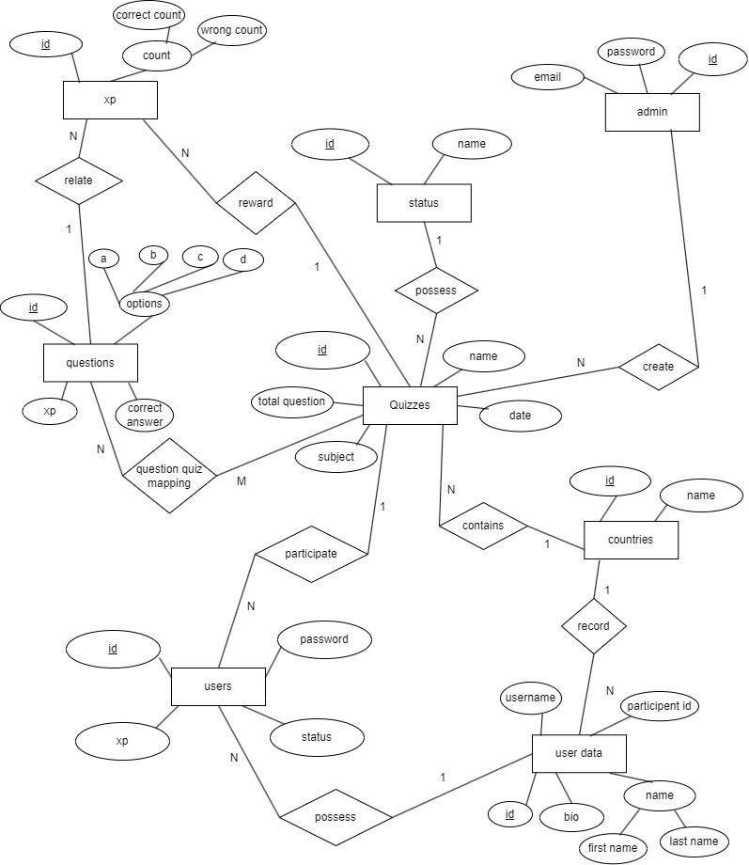

**Schema Diagram**

